The Jakarta Project creates and maintains open source software for the Java platform. It operates as an umbrella project under the auspices of the Apache Software Foundation, and all Jakarta products are released under the Apache License. As of December 21, 2011 the Jakarta project has been retired because no subprojects are remaining.

Sun Microsystems, Inc.

The initial design for what became Sun's first Unix workstation, the Sun-1, was conceived by Andy Bechtolsheim when he was a graduate student at Stanford University in Palo Alto, California. Bechtolsheim originally designed the SUN workstation for the Stanford University Network communications project as a personal CAD workstation. It was designed around the Motorola 68000 processor with an advanced memory management unit (MMU) to support the Unix operating system with virtual memory support.[6] He built the first ones from spare parts obtained from Stanford's Department of Computer Science and Silicon Valley supply houses.[7]
On February 24, 1982, Vinod Khosla, Andy Bechtolsheim, and Scott McNealy, all Stanford graduate students, founded Sun Microsystems. Bill Joy of Berkeley, a primary developer of the Berkeley Software Distribution (BSD), joined soon after and is counted as one of the original founders.[8] The Sun name is derived from the initials of the Stanford University Network.[9][10][11] Sun was profitable from its first quarter in July 1982.
Sun's initial public offering was in 1986 under the stock symbol SUNW, for Sun Workstations (later Sun Worldwide).[12][13] The symbol was changed in 2007 to JAVA; Sun stated that the brand awareness associated with its Java platform better represented the company's current strategy.[14]
Sun's logo, which features four interleaved copies of the word sun, was designed by professor Vaughan Pratt, also of Stanford. The initial version of the logo was orange and had the sides oriented horizontally and vertically, but it was subsequently redesigned so as to appear to stand on one corner and the color changed to purple, and later blue.
The "Bubble" and its aftermath[edit]
In the dot-com bubble, Sun began making much more money, and its shares rose dramatically. It also began spending much more, hiring workers and building itself out. Some of this was because of genuine demand, but much was from web start-up companies anticipating business that would never happen. In 2000, the bubble burst.[15] Sales in Sun's important hardware division went into free-fall as customers closed shop and auctioned off high-end servers.
Several quarters of steep losses led to executive departures, rounds of layoffs,[16][17][18] and other cost cutting. In December 2001, the stock fell to the 1998, pre-bubble level of about $100. But it kept falling, faster than many other tech companies. A year later it had dipped below $10 (a tenth of what it was even in 1990) but bounced back to $20. In mid-2004, Sun closed their Newark, California factory and consolidated all manufacturing to Hillsboro, Oregon.[19] That factory later closed, in 2006.[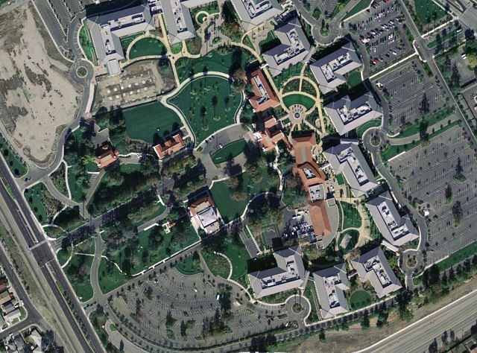

On March 12, 2014, Kodak announced that the Board of Directors had elected Jeffrey J. Clarke as Chief Executive Officer and a member of its Board of Directors. [23] [24]

